Contents
PART A:LITERATURE REVIEW 2
a) Literature review on data repository tools 2
1. Semantic Web Technologies: 3
2. RDF (Resource Description Framework) 4
3. SPARQL() 4
4. MongoDB 5
5. AWS 6
6. Azure: 7
b) Comprehensive review and survey of sample research works 7
Data warehouse: 7
Data Integration 8
1.Unstructured Data Integration: 8
2.Snowflake Hybrid Data Warehouse: 8
3.PART B:GROUP COMPONENT 8
PHASE I 9
PHASE II 10
Star Schema of Data Warehouse 10
Tables using MySQL (see Appendix D) 10
Inserting Data into Tables (see Appendix E) 12
Graphical user interface (GUI) (see Appendix F) 12
SQL queries for Reports 13
Machine learning model 15
PART-C: INDIVIDUAL COMPONENT -BIG DATA APPLICATION AND ANALYTICS 16
References 18
Appendix A – Draft / Earlier versions of EERD 21
Appendix B – Feedback Received on EERD 22
Appendix C – Explanation of implementation of feedback 22
Appendix D – Complete code for Part-A Phase-II 23
Appendix E – Complete code for Part-B Phase-II 26
Appendix F – Complete code for Part-C Phase-II 30
Appendix E – Complete code for Part-E Phase-II 43

Include a table of figures.
This can also be automated just like table of contents. For example, see these instr
Figure 1 : Enhanced Entity Relationship Diagram 9
Figure 2 : Start-schema for data warehousing 9
Figure 3: database created 10
Figure 4: SQL Queries_creatin tables 10
Figure 5: Tables created in DB 11
Figure 6: Inserting data SQL Queries 11
Figure 7: data added to Tables via Python 12
Figure 8: Tkinter- Application GUI 13
Figure 9: importing packages and splitting data for Model 15
Figure 10: Regressor Model training and testing 15
Figure 11: Data frame head Entries 16
Figure 12: Model Performance Matrix 16
Figure 13: Draft-version-EERD 21
Figure 14: feedback-on-EERD 22
uctions for how to create a list of figures in Microsoft Word.

PART A:LITERATURE REVIEW

a) Literature review on data repository tools

Structured Data:
Structured data is data or information that is well-organized and can be categorized into columns and rows. Typically, this is in the form of text files. Data mining tools readily consume this type of data, which can be inserted into relational database management systems (RDBMS). Structured data is data that is entirely organized, with each element being appropriately named and easily accessible. Structured data is the primary objective of the majority of conventional relational database management systems (RDBMS) (Mishra, S. and Misra).

Unstructured data:
Unstructured data is inherently incomplete and disorganized. Nevertheless, most of the unstructured data will be converted to structured data. To accomplish this, there is a necessity for transforming and processing costs, as well as an increase in the time required to convert data into semi-structured or structured formats. It is a significant possibility that not all types of unstructured data can be easily converted into structured data for the purpose of analytics (Mishra, S. and Misra).

1. Semantic Web Technologies:
The Semantic Web is defined by the sharing of data and facts instead of the text of a page. Sir Tim Berners-Lee introduced the concept of a Semantic Web in 2001. The Semantic Web assists in the development of a technology stack that supports a "web of data" not to "web of documents." The objective of the web of data is to enable the computer to perform more significant tasks and to create systems that can facilitate trusted interactions over the network. The main technologies consist of SPARQL and RDF (Present and future of semantic web technologies).
Advantages:
- The Semantic Web is a significant advancement in the evolution of the web, transitioning from a web of documents to a web of data. The Semantic Web endeavours to improve the accessibility and usability of data, thereby facilitating collaboration between humans and machines, through the utilization of technologies such as RDF, SPARQL, and OWL (Present and future of semantic web technologies).
- Enhanced Data Integration: The Semantic Web facilitates the seamless exchange and interoperability of data from disparate sources, which is achieved by breaking down silos.
- Improved Search and Discovery: Semantic metadata enables search engines to more effectively comprehend the context and significance of information, resulting in more pertinent and precise search results. This is advantageous for search engine optimization purposes.
Disadvantages:
- Scalability: The capacity to manage substantial quantities of data.
- Visualization: The process of presenting data in a manner that is easily comprehensible.
- Ontology Development: The process of establishing and revising ontologies (Semantic Web Learn how it’s Revolutionizing Web Technologies).

2. RDF (Resource Description Framework)
The Resource Description Framework (RDF) is an extensive platform for the arrangement of interconnected data on the web. RDF statements are employed to describe and exchange metadata, facilitating the standardized exchange of data based on relationships (What is RDF (Resource Description Framework?, no date).
A set of RDF statements of the form (subject, predicate, object) triples, also known as (subject, property, value), is used to describe a specific resource in RDF. The resource is the subject, the predicate is the characteristic being described, and the object is the value associated with that characteristic (Sakr, S. and Al-Naymat .et all).
Advantages:
- The distribution of metadata regarding internet resources is promoted by a uniform framework.
- The standard syntax and query capability facilitate the exchange of information between applications.
- Compared to indexes derived from full-text gathering, searchers obtain more precise results when they search based on metadata (What is RDF (Resource Description Framework?,).
Disadvantages:
- It can be challenging to establish a standardized vocabulary for the description of RDF resources. The Dublin Core Metadata Initiative is a significant endeavour to standardize RDF elements and terms for common entities and attributes.
- It requires practice to determine the most suitable syntax format for RDF statements. For specific implementations, such as those that generate RDF statements, alternative formats may be more user-friendly.
- The selection of the most suitable RDF query language for an application is contingent upon the application's specific requirements and the query language's capabilities (What is RDF (Resource Description Framework?, no date).

3. SPARQL()
The SPARQL Protocol and RDF Query Language (SPARQL) is a powerful query language that is employed to retrieve and manipulate data that is stored in RDF format. SPARQL, which was created by the W3C, is crucial for querying semantic web and linked data (SPARQL Query Language for RDF, 2013).
It is composed of triple patterns that are similar to RDF triples, support flexible query forms (SELECT, CONSTRUCT, ASK, DESCRIBE), filter expressions, optional patterns, and UNION operations, enabling the execution of complex queries and data aggregation.
Advantages.
- SPARQL utilizes graph pattern matching to navigate relationships in RDF graph data. Simplicity can be combined with complexity in this process, allowing for the examination of more intricate relationships within the data (SPARQL Query Language for RDF (2013).
- SPARQL queries are not limited to a single database. Linked queries enable users to access numerous datasets (Petkova, 2019).
- Expressive power: It is possible to construct intricate queries that integrate a variety of patterns to extract specific information from the RDF graph.

Disadvantages:

- Query Complexity: The development of intricate SPARQL queries necessitates a learning curve for AI practitioners, as it necessitates a high level of expertise and a meticulous examination of RDF data structures.
- Performance Overhead: The execution of federated SPARQL queries across distributed data sources may result in performance overhead, which may require optimization for large-scale AI applications (Lark Editorial Team, 2023).

4. MongoDB
MongoDB is a general-purpose database that is scalable, flexible, and powerful. It incorporates features such as geospatial indexes, sorting, aggregations, range queries, and secondary indexes to enable scaling out. This chapter delves into the primary design decisions that have contributed to the unique characteristics of MongoDB (Bradshaw, S,et.all).
Modern functionalities, including evolving schemas, scalable data distribution, high-speed complex querying, robust analytics support, and flexible deployment options, are available in NoSQL databases such as MongoDB, which are specifically designed to address the complex data problems of the internet era. The databases can store relational data efficiently ().
Advantages:
- User-Friendliness: MongoDB's document-oriented model enables the creation of data structures that are schema-less and flexible, thereby enabling rapid development and iteration (The Best NoSQL Database To Use In 2021).
- Designed for Scalability: MongoDB is engineered to automatically balance data and load within a cluster by scaling out across multiple servers (The Best NoSQL Database To Use In 2021).
- Feature-Rich: MongoDB facilitates the management of data by providing advanced indexing, aggregation frameworks, and specialized collection types (The Best NoSQL Database To Use In 2021).
Disadvantages:
- Transactions: MongoDB's dependence on multi-document ACID transactions can result in data corruption if not properly managed, as numerous applications do not necessitate them (Ultimate Guide MongoDB).
- Complex and time-consuming operations are the result of MongoDB's lack of native join support, which necessitates manual coding for data aggregation (Ultimate Guide MongoDB).
- MongoDB's flexibility for large and deeply nested documents is restricted by its restriction of document size to 16 MB and nesting levels to 100 (Ultimate Guide MongoDB).

5. AWS
Amazon Web Services (AWS) is the industry leader in cloud computing. The infrastructure and performance of AWS are investigated in this study through the use of passive network analysis. CloudFront exhibits superior performance through effective caching and load balancing, while the Virginia data centre manages the majority of EC2 and S3 traffic. However, it is less efficient for Italian users. These discoveries facilitate the optimization of cloud deployments and design (Bermudez, I., Traverso,et,all).
Advantages:
- AWS provides a broad range of options for users in terms of the environment's capabilities (AWS vs. MWA).
- AWS provides the opportunity to develop applications in any language, provided that the AMIs can be constructed to accommodate them (AWS vs. MWA).
- AWS provides the user with complete control over the hardware and all applications that run on it (AWS vs. MWA).
Disadvantages:
- As users continue to utilize AWS, they encounter a significant learning curve. The user faces a significant learning curve when utilizing AWS ((AWS vs. MWA).).
- To complete tasks, users and developers must navigate numerous obstacles when utilizing AWS (AWS vs. MWA).
- Users are required to assume a significant amount of responsibility for the maintenance of the servers, as AWS provides complete control over the hardware (AWS vs. MWA).

6. Azure:
Azure, previously Windows Azure, is Microsoft's public cloud platform offering services in compute, analytics, storage, and networking. Businesses can use Azure to develop, scale, and manage applications with flexibility in choosing tools and technologies, including open-source options. It supports IaaS, PaaS, SaaS, and serverless functions, charging on a pay-as-you-go basis. Subscribers access services via the Azure portal to create and manage cloud resources like VMs and databases (Bigelow, 2022).
Advantages:
- Azure provides scalable solutions that enable businesses to effortlessly adjust the computing power as required, paying only for the resources used without the need to purchase upgrades (Sahana, 2022).
- Azure guarantees continuous data availability by providing access to a diverse array of global data centres and incorporating multiple redundancies. This enables seamless data access even during the maintenance of individual centres (Gaille, 2018).

Disadvantages:
- Complexity of Management: Azure necessitates specialized knowledge to optimize and effectively manage resources, which can be both costly and complex for larger organizations (Jebaraj, 2024).

b) Comprehensive review and survey of sample research works

Data warehouse:
A data warehouse is an enterprise system that employs structured and semi-structured data from a variety of sources, including marketing automation, customer relationship management, point-of-sale transactions, and more, to analyze and report on the data. A data warehouse is well-suited for custom reporting and ad hoc analysis (Google, no date).

Data Integration
Structured Data Integration:
The integration of structured data entails the evaluation of data representation models and the extraction of metadata from relational DBMSs. The process is optimized by AI, which recommends integration keys based on metadata, taking into account the feasibility of the data and previous integrations. The DROP algorithm is used to filter noise, thereby enhancing relevance and accuracy, as the ETL process unifies the data into a single repository (Turet, J.G. and Costa,et all).

1.Unstructured Data Integration:
Unstructured data integration employs the Dublin Core schema to evaluate models using metadata extractors for non-relational DBMSs and federated databases. AI enhances integration by proposing keys that are determined by metadata. The data is unified by the ETL process, and the DROP algorithm reduces noise to enhance the accuracy of machine learning and the relevance of the data (Turet, J.G. and Costa,et all).

2.Snowflake Hybrid Data Warehouse:
Snowflake's support for semi-structured and unstructured data, as well as multiple data models such as Data Vault and dimensional, organizations can manage a wide range of data sources for a variety of business applications. This allows companies to analyze data sets such as social media feeds, sensor data, and customer feedback in addition to traditional transactional data (Van, 2022).

3.PART B:GROUP COMPONENT
Group Members
Baljit Singh | w2044032
Luka Imedashvili | w1919474
Samuel Effiom | w2038116
Muhammad Usama | W2050885
Zain UL Abideen | W2059328

PHASE I

Conceptual Enhanced Entity Relationship Diagram
Earlier Version of EERD (See Appendix A)
Feedback Received (see Appendix B)
Explanation of Changes (see Appendix C)
Final EERD
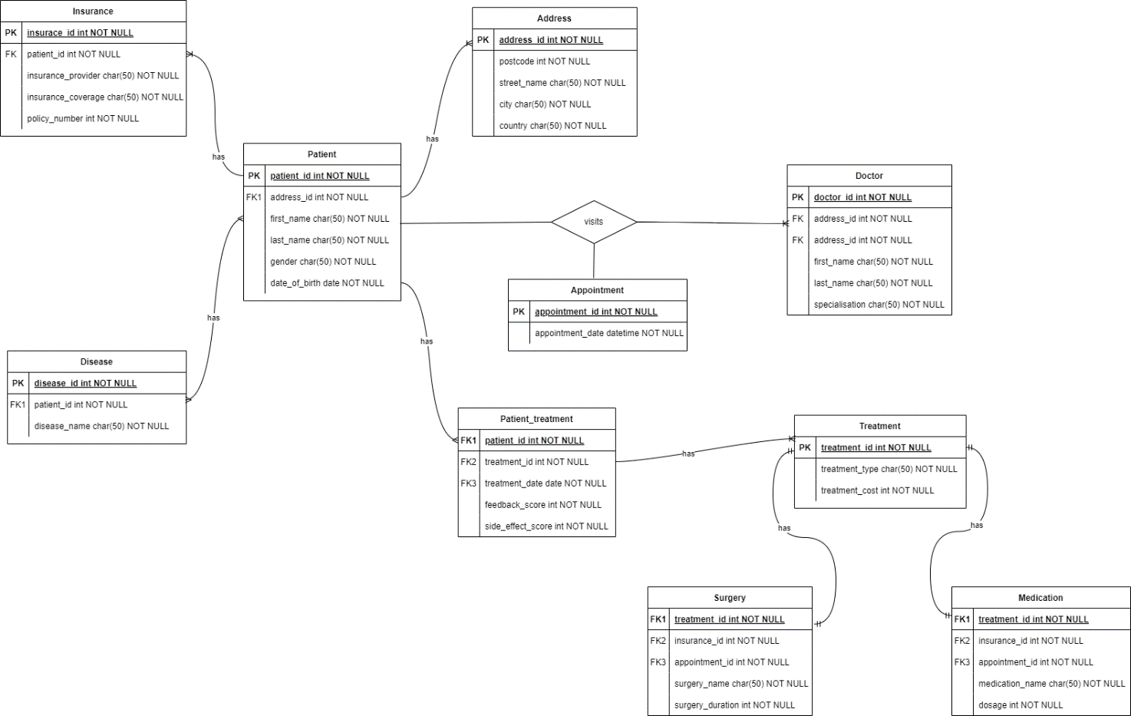
Figure 1 : Enhanced Entity Relationship Diagram

PHASE II

Star Schema of Data Warehouse
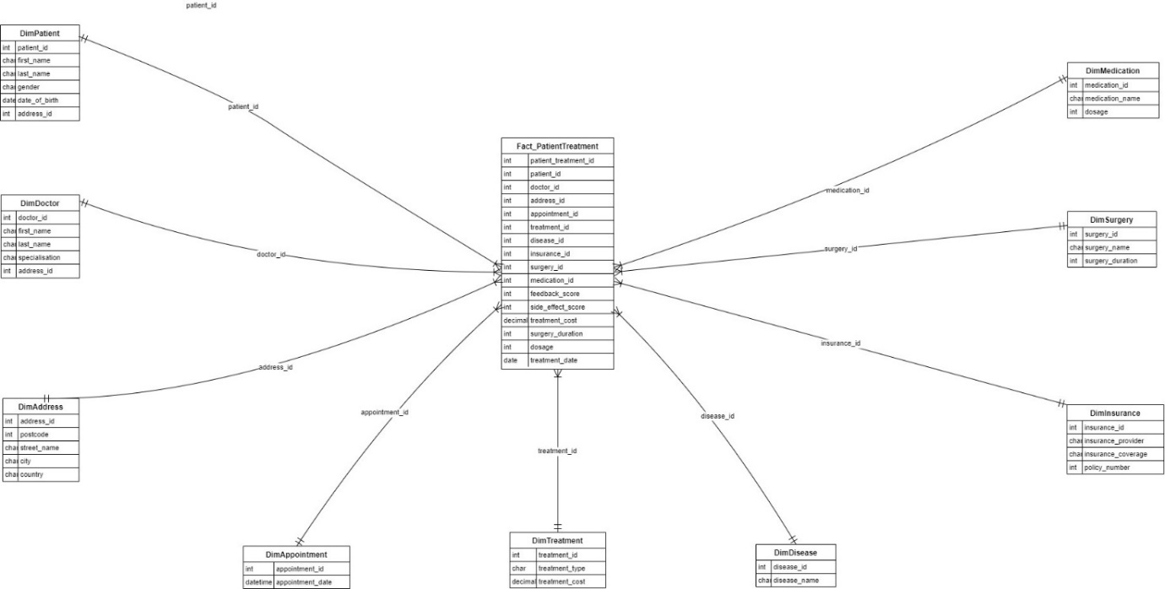
Figure 2 : Start-schema for data warehousing

Tables using MySQL (see Appendix D)
Creating database healthcare
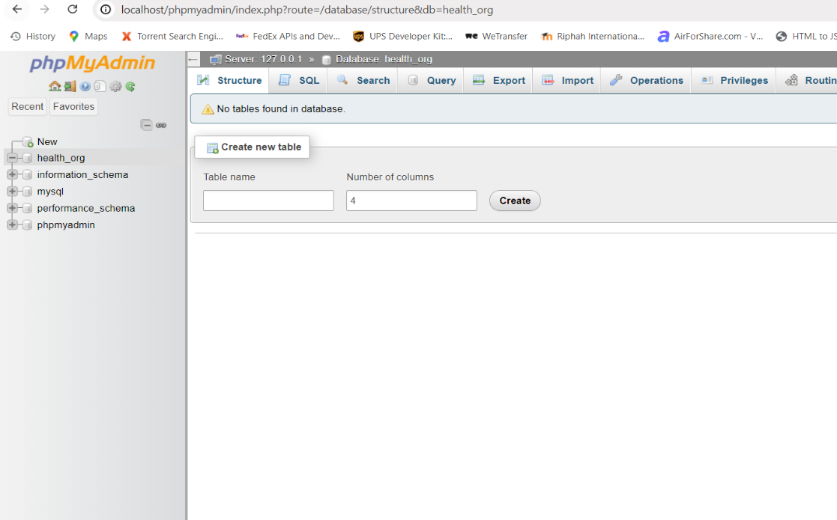
Figure 3: database created
Creating tables
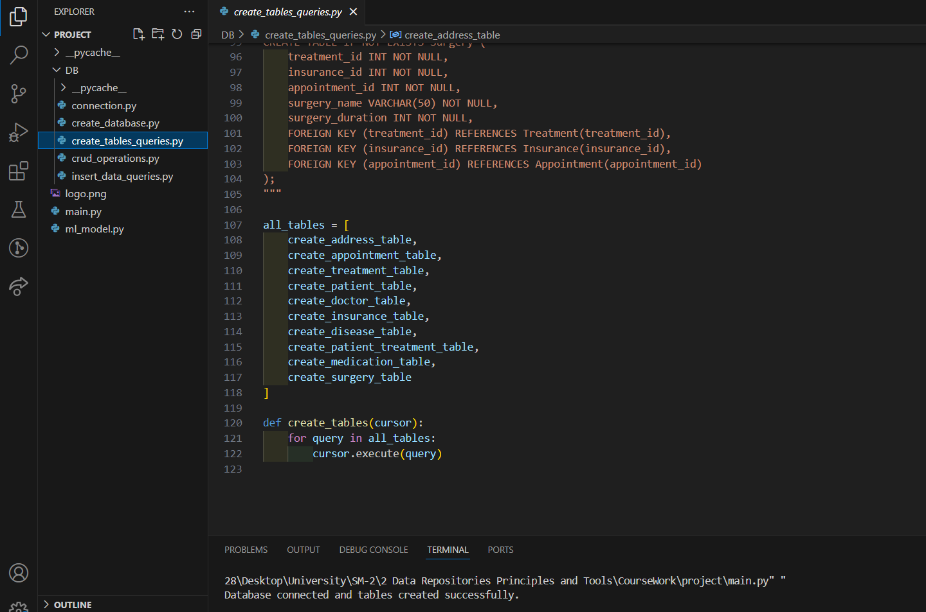
Figure 4: SQL Queries_creatin tables
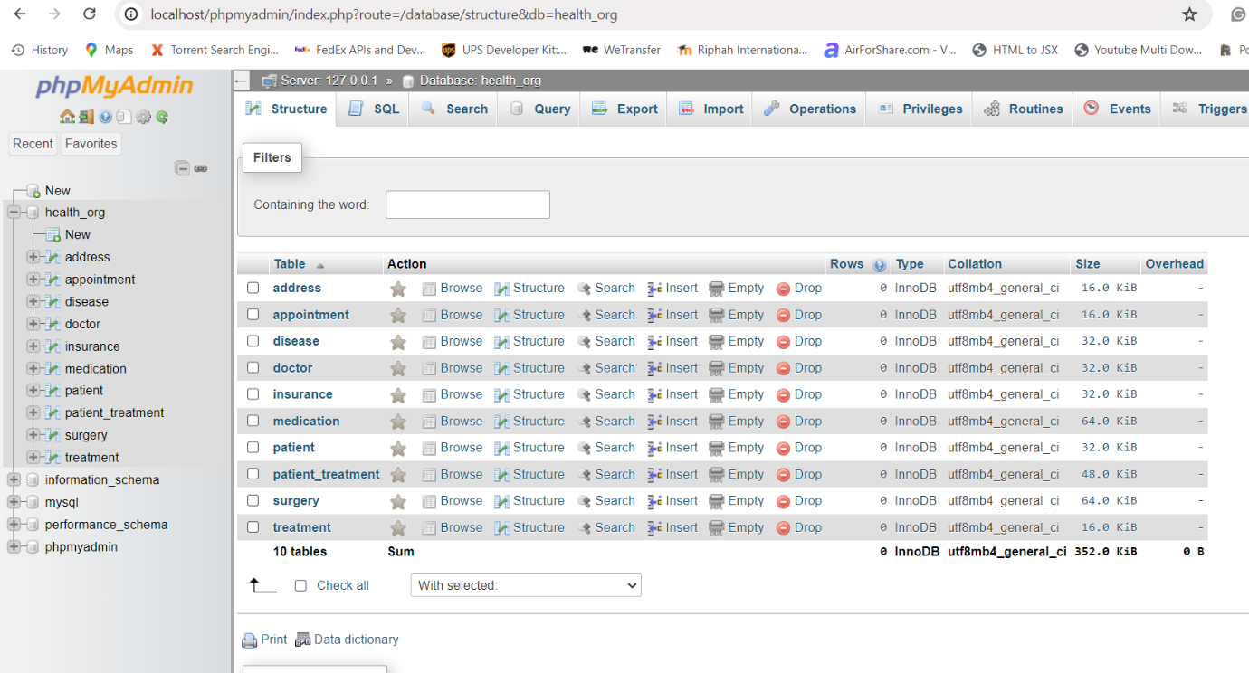
Figure 5: Tables created in DB

Inserting Data into Tables (see Appendix E)
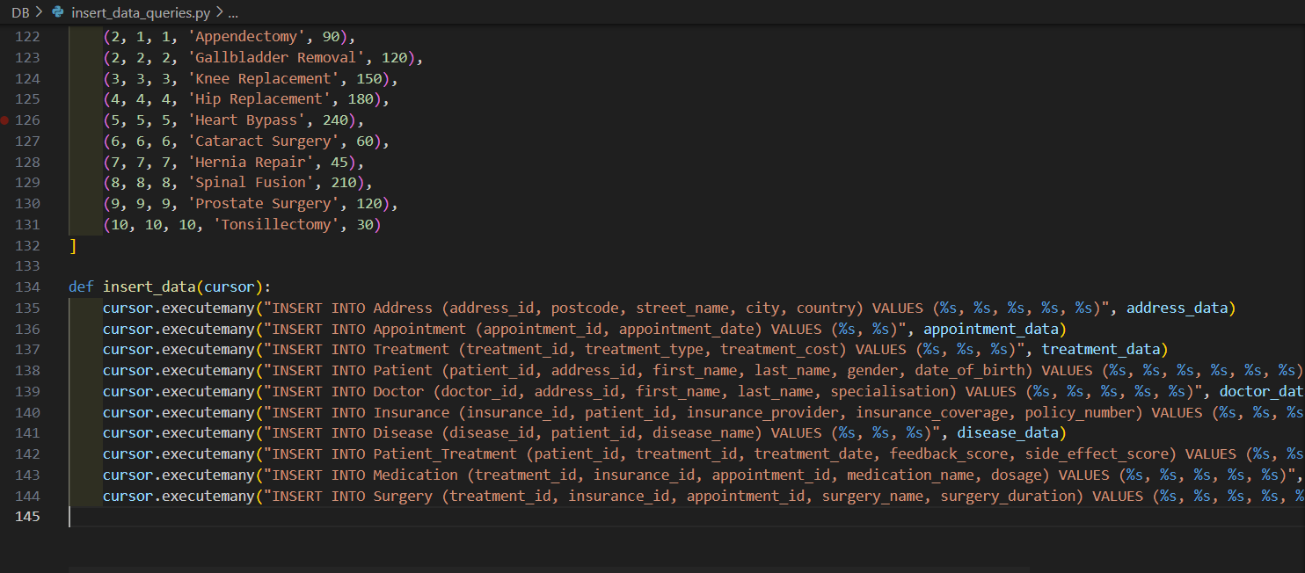
Figure 6: Inserting data SQL Queries
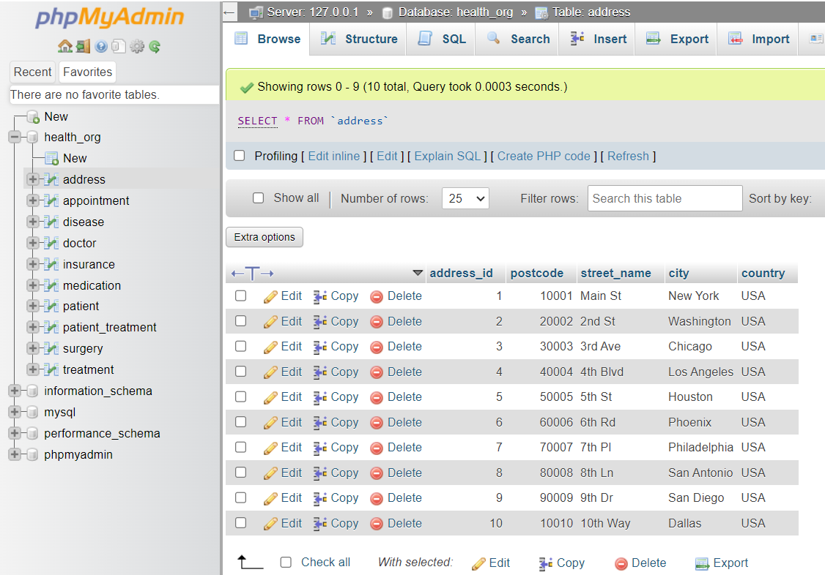
Figure 7: data added to Tables via Python

Graphical user interface (GUI) (see Appendix F)
https://westminster.cloud.panopto.eu/Panopto/Pages/Viewer.aspx?id=a49de9cc-62d5-4386-8594-b1b70142ea94

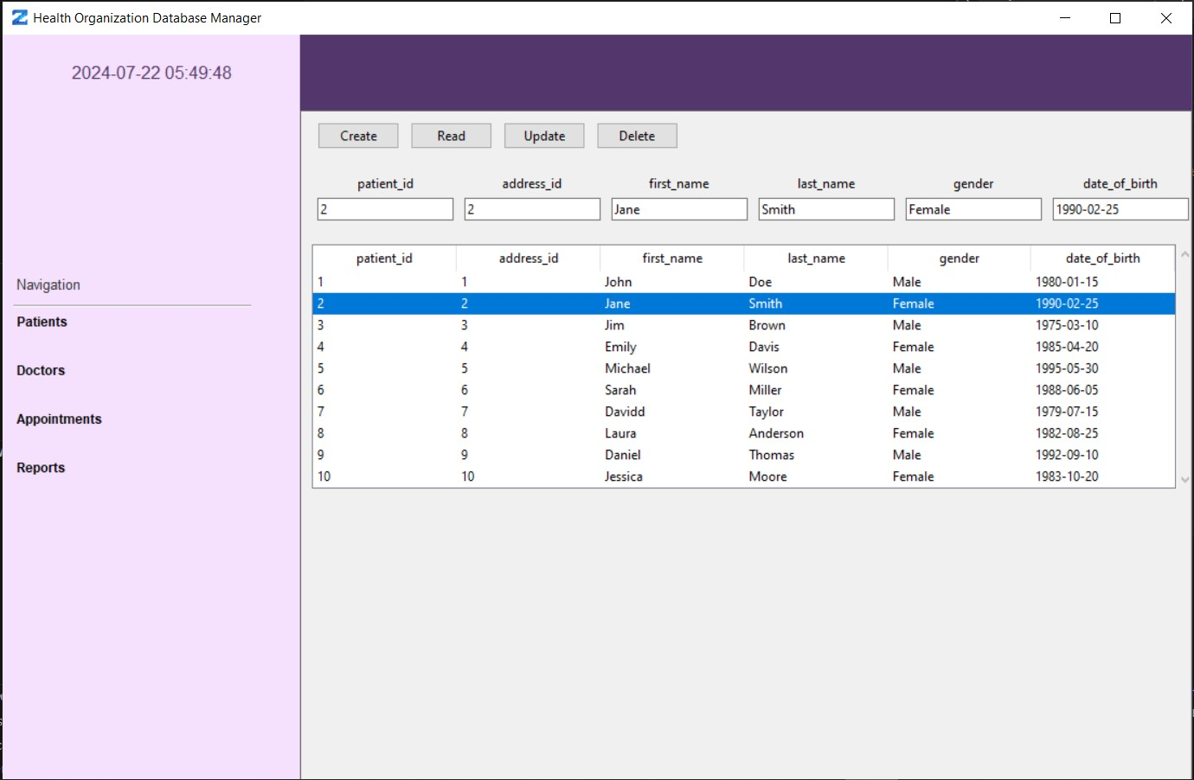
Figure 8: Tkinter- Application GUI

SQL queries for Reports
https://westminster.cloud.panopto.eu/Panopto/Pages/Viewer.aspx?id=a49de9cc-62d5-4386-8594-b1b70142ea94

Table 1: Reports and Queries Table
Report Title | Description | SQL Query
List of All Patients | Retrieves basic information for all patients | SELECT patient_id, first_name, last_name, gender, date_of_birth FROM Patient
List of All Doctors with Their Specializations | Retrieves basic information and specialization for all doctors | SELECT doctor_id, first_name, last_name, specialisation FROM Doctor
Appointments Scheduled for a Specific Date | Retrieves appointment details for a specified date | SELECT appointment_id, appointment_date FROM Appointment WHERE appointment_date = ‘2024-07-19’
Treatments Provided to Each Patient | Retrieves treatment details and feedback for each patient | SELECT p.patient_id, p.first_name, p.last_name, t.treatment_type, pt.feedback_score, pt.side_effect_score FROM Patient_Treatment pt JOIN Patient p ON pt.patient_id = p.patient_id JOIN Treatment t ON pt.treatment_id = t.treatment_id
Patients with Insurance Details | Retrieves insurance details for each patient | SELECT p.patient_id, p.first_name, p.last_name, i.insurance_provider, i.policy_number FROM Patient p JOIN Insurance i ON p.patient_id = i.patient_id
Doctors and Their Patients | Retrieves doctor and their corresponding patients based on address | SELECT d.doctor_id, d.first_name, d.last_name, p.patient_id, p.first_name, p.last_name FROM Doctor d JOIN Patient p ON d.address_id = p.address_id
List of All Treatments with Their Costs | Retrieves all treatments and their costs | SELECT treatment_id, treatment_type, treatment_cost FROM Treatment
Insurance Coverage Summary | Retrieves insurance coverage summary grouped by insurance provider | SELECT i.insurance_provider, COUNT(i.policy_number) AS policy_count, SUM(i.insurance_coverage) AS total_coverage FROM Insurance i GROUP BY i.insurance_provider
Diseases Diagnosed in Patients | Retrieves diseases diagnosed in each patient | SELECT p.patient_id, p.first_name, p.last_name, d.disease_name FROM Disease d JOIN Patient p ON d.patient_id = p.patient_id
List of Appointments with Associated Treatments | Retrieves appointments and associated treatments, including medications and surgeries | SELECT a.appointment_id, a.appointment_date, t.treatment_type FROM Appointment a JOIN Medication m ON a.appointment_id = m.appointment_id JOIN Treatment t ON m.treatment_id = t.treatment_id UNION SELECT a.appointment_id, a.appointment_date, t.treatment_type FROM Appointment a JOIN Surgery s ON a.appointment_id = s.appointment_id JOIN Treatment t ON s.treatment_id = t.treatment_id

Machine learning model
Predicting Treatment Cost (see Appendix G)
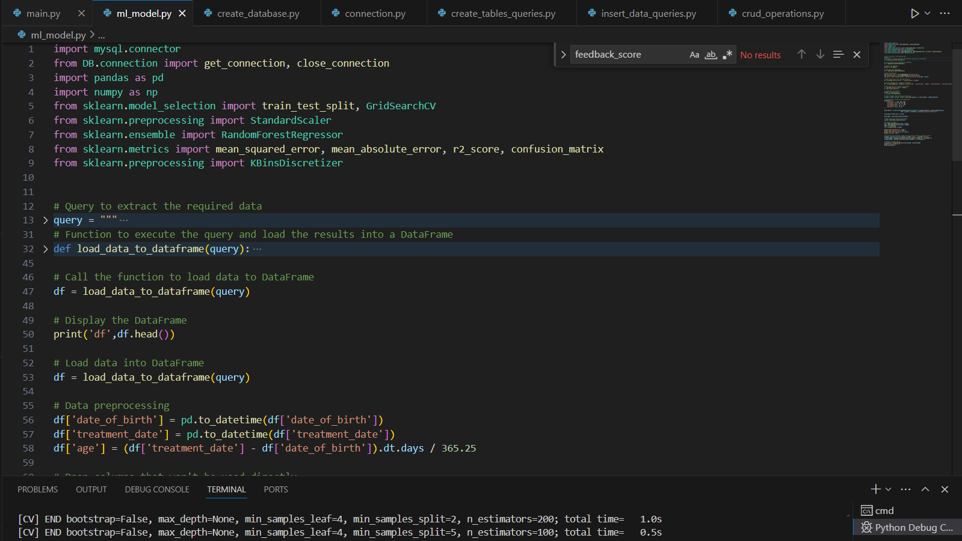
Figure 9: importing packages and splitting data for Model
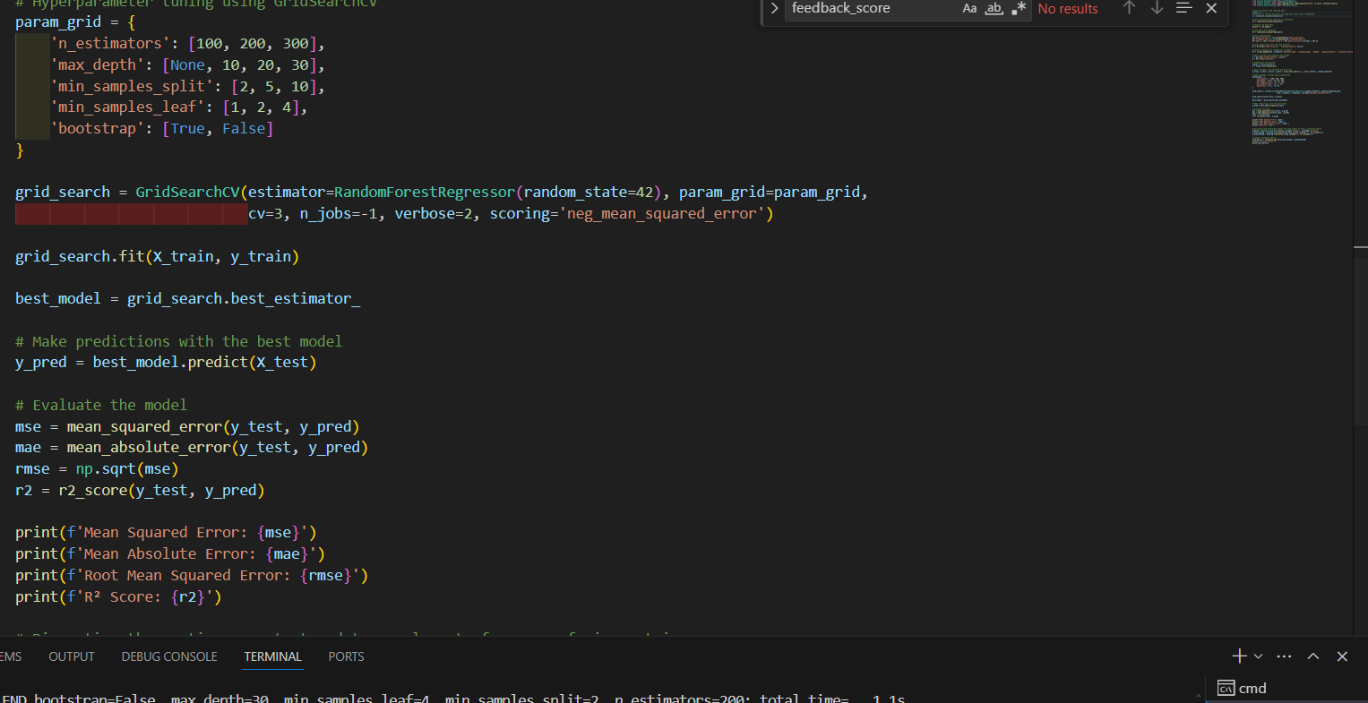
Figure 10: Regressor Model training and testing
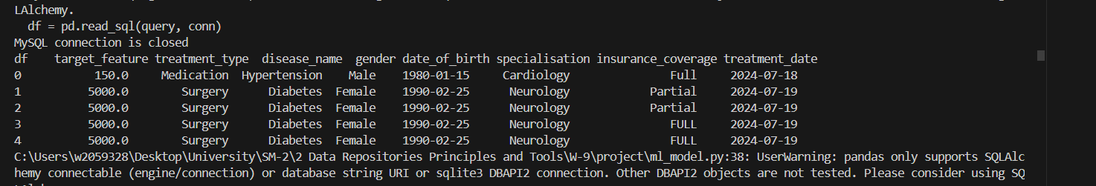
Figure 11: Data frame head Entries
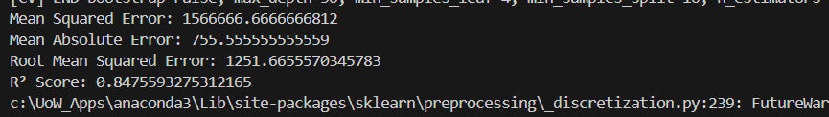
Figure 12: Model Performance Matrix
the regression model performs reasonably well with an R² score of 0.847, which indicates that the model explains about 84.7% of the variance in the treatment cost. However, the Mean Squared Error and Mean Absolute Error values suggest room for improvement.

PART-C: INDIVIDUAL COMPONENT -BIG DATA APPLICATION AND ANALYTICS

a) Create a Hadoop test environment in Google Colab. Write a Hadoop MapReduce program inPython and test it with a choice of your dataset. You can use a plain text dataset like a book from Project Gutenberg.
https://colab.research.google.com/drive/1auI78i4aFZdi0YU85IkIm1023-CkFsv3?usp=sharing
b) Set up a single-node Hadoop cluster on Google Colab and run MapReduce example using Python.
https://colab.research.google.com/drive/1QDvOEDNkXR-WKX8K2Psz_yl5SCJlmfg0?usp=sharing
c) Show an application of Data Generation and Aggregation with Python's Faker Library and PySpark.
https://colab.research.google.com/drive/1BMqfcmHC-vIuDHzJG74GkR4ymIA83nrn?usp=sharing
d) Set up a single-node standalone Spark server on Google Colab including Web UI and History Server.
https://colab.research.google.com/drive/1OYcnp1ArNPqUBl62Darn23Amo_iaZTq_?usp=sharing
e) Set up a Schema for Spark in Google Colab and apply any three SQL queries.
https://colab.research.google.com/drive/1P7vfCkKLG2zzdo2duFdzQy4gAVCS3k46?usp=sharing

References
List your references in this section using Harvard referencing style.

- Patel, A. and Jain, S., 2021. Present and future of semantic web technologies: a research statement. International Journal of Computers and Applications, 43(5), pp.413-422.
- Semantic Web 🌐 Learn how it’s Revolutionizing Web Technologies 2024. (no date). Sierratech | Custom Software Product Development. Available from https://sierratech.io/semantic-web/#What_is_the_Semantic_Web [Accessed 24 July 2024].
- What is RDF (Resource Description Framework)? (no date). SearchAppArchitecture. Available from https://www.techtarget.com/searchapparchitecture/definition/Resource-Description-Framework-RDF#:~:text=The%20Resource%20Description%20Framework%20(RDF.
- Sakr, S. and Al-Naymat, G., 2010. Relational processing of RDF queries: a survey. ACM Sigmod Record, 38(4), pp.23-28.
- SPARQL Query Language for RDF. (2013). W3.org. Available from https://www.w3.org/TR/rdf-sparql-query/.
- Petkova, T. (2019). Data, Databases and Deeds: A SPARQL Query to the Rescue. Ontotext. Available from https://www.ontotext.com/blog/data-databases-sparql-query/#:~:text=SPARQL%20queries%20are%20not%20constrained [Accessed 24 July 2024].
- Lark Editorial Team. (2023). Sparql. Larksuite.com. Available from https://www.larksuite.com/en_us/topics/ai-glossary/sparql [Accessed 24 July 2024].
- Bradshaw, S., Brazil, E. and Chodorow, K., 2019. MongoDB: the definitive guide: powerful and scalable data storage. O'Reilly Media.
- The Best NoSQL Database To Use In 2021. MongoDB. Available from https://www.mongodb.com/resources/basics/databases/nosql-explained/best-nosql-database [Accessed 24 July 2024].
- Ultimate Guide MongoDB: Definition, Advantages & Disadvantages. (no date). knowledgenile. Available from https://www.knowledgenile.com/blogs/pros-and-cons-of-mongodb.
- Bermudez, I., Traverso, S., Mellia, M. and Munafo, M., 2013, April. Exploring the cloud from passive measurements: The Amazon AWS case. In 2013 Proceedings IEEE INFOCOM (pp. 230-234). IEEE.
- Bhargavi, K. and Sharma, O., 2012. AWS vs. MWA: A review. International Journal of Engineering Research & Technology (IJERT), 1(9), pp.1-7.
- Bigelow, S. (2022). What is Microsoft Azure and How Does It Work? SearchCloudComputing. Available from https://www.techtarget.com/searchcloudcomputing/definition/Windows-Azure.
- Sahana. (2022). 8 Pros and Cons of Using Microsoft Azure Cloud Services. Tech Quintal. Available from https://www.techquintal.com/advantages-and-disadvantages-of-azure/.
- Gaille, B. (2018). 15 Microsoft Azure Advantages and Disadvantages. BrandonGaille.com. Available from https://brandongaille.com/15-microsoft-azure-advantages-and-disadvantages/.
- Jebaraj, K. (2024). Microsoft Azure Advantages and Disadvantages. www.knowledgehut.com. Available from https://www.knowledgehut.com/blog/cloud-computing/microsoft-azure-advantages-and-disadvantages.
- Mishra, S. and Misra, A., 2017, September. Structured and unstructured big data analytics. In 2017 International Conference on Current Trends in Computer, Electrical, Electronics and Communication (CTCEEC) (pp. 740-746). IEEE.
- Google. (no date). What is a Data Warehouse? Google Cloud. Available from https://cloud.google.com/learn/what-is-a-data-warehouse.
- https://www.softwareag.com/en_corporate/resources/data-integration/article/data-ingestion.html
- What is ETL (Extract, Transform, Load)? | IBM. (2021). www.ibm.com. Available from https://www.ibm.com/topics/etl#:~:text=What%20is%20ETL%3F [Accessed 25 July 2024].
- Turet, J.G. and Costa, A.P.C.S., 2022. Hybrid methodology for analysis of structured and unstructured data to support decision-making in public security. Data & Knowledge Engineering, 141, p.102056.
- Van, N. (2022). Snowflake - A Hybrid of Data Warehouse and Data Lake. Snowflake. Available from https://www.snowflake.com/blog/data-cloud-hybrid-data-warehouse-data-lake/#:~:text=Mixed%20data%20types%3A%20While%20most [Accessed 25 July 2024].

Appendix A – Draft / Earlier versions of EERD
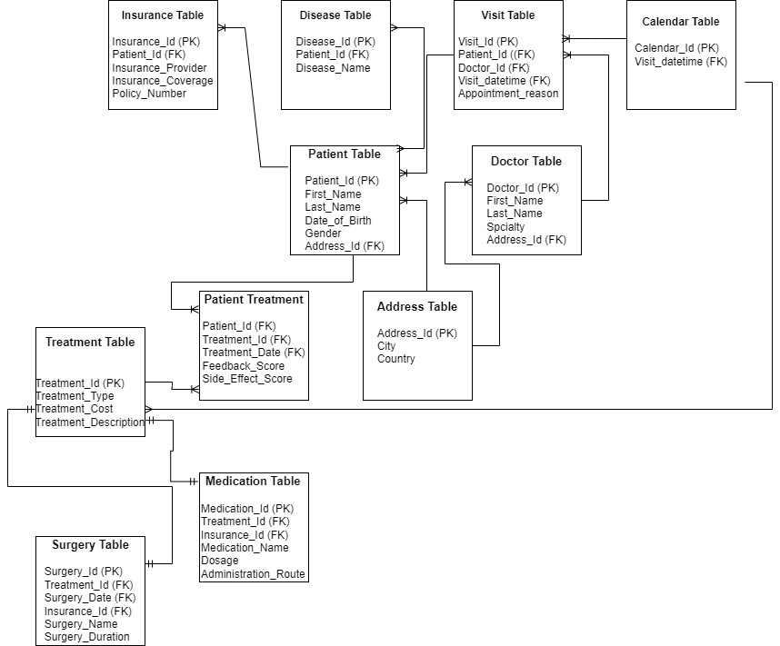
Figure 13: Draft-version-EERD

Appendix B – Feedback Received on EERD
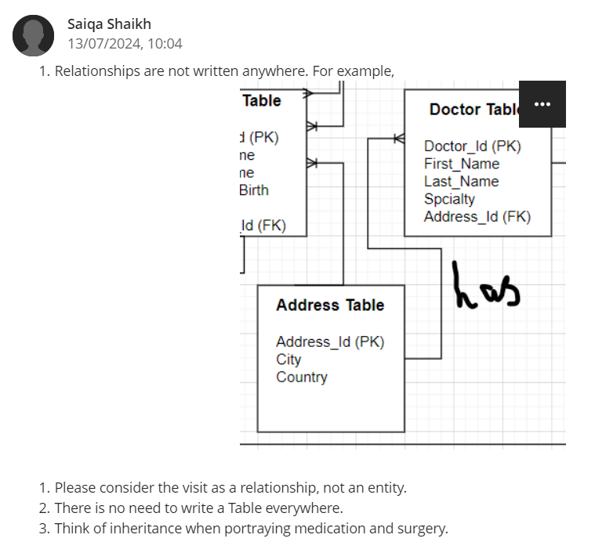
Figure 14: feedback-on-EERD

Appendix C – Explanation of implementation of feedback
- Address Integration:
  - Initially, the address details were spread across multiple tables.
  - Now, the Address Table is succinctly referenced, with direct foreign keys linking to the Patient and Doctor tables. This avoids redundancy and maintains clarity.
- Visit as a Relationship:
  - The Visit Table was initially an entity, but now visits are treated as a relationship between Patient and Appointment, enhancing the relational model.
  - This change clarifies that visits are specific instances of patient-doctor interactions, simplifying the design and improving normalization.
- Treatment Inheritance:
  - The Medication and Surgery tables inherit attributes from the Treatment Table, indicating a clear hierarchy.
  - This design acknowledges shared properties (e.g., treatment_id) while allowing for specific attributes unique to medications and surgeries (e.g., dosage for Medication and surgery_duration for Surgery).

Appendix D – Complete code for Part-A Phase-II
Create database
import mysql.connector
from mysql.connector import errorcode

def create_database(db_name='HEALTH_ORG'):
try:
conn = mysql.connector.connect(
host="127.0.0.1",
user="root",
password=""
)
cursor = conn.cursor()
cursor.execute(f"CREATE DATABASE {db_name}")
print(f"Database '{db_name}' created successfully.")
except mysql.connector.Error as err:
if err.errno == errorcode.ER_ACCESS_DENIED_ERROR:
print("Something is wrong with your user name or password")
elif err.errno == errorcode.ER_BAD_DB_ERROR:
print("Database does not exist")
else:
print(err)
finally:
if conn.is_connected():
cursor.close()
conn.close()

Create Connection database
import mysql.connector

def get_connection():
conn = mysql.connector.connect(
host="127.0.0.1",
user="root",
password="",
database="HEALTH_ORG"
)
return conn

def close_connection(connection):
if connection and connection.is_connected():
connection.close()
print("MySQL connection is closed")
Create Table
create_address_table = """
CREATE TABLE IF NOT EXISTS Address (
address_id INT NOT NULL AUTO_INCREMENT PRIMARY KEY,
postcode INT NOT NULL,
street_name VARCHAR(50) NOT NULL,
city VARCHAR(50) NOT NULL,
country VARCHAR(50) NOT NULL
);
"""

create_appointment_table = """
CREATE TABLE IF NOT EXISTS Appointment (
appointment_id INT NOT NULL AUTO_INCREMENT PRIMARY KEY,
appointment_date DATETIME NOT NULL
);
"""

create_treatment_table = """
CREATE TABLE IF NOT EXISTS Treatment (
treatment_id INT NOT NULL AUTO_INCREMENT PRIMARY KEY,
treatment_type VARCHAR(50) NOT NULL,
treatment_cost FLOAT NOT NULL
);
"""

create_patient_table = """
CREATE TABLE IF NOT EXISTS Patient (
patient_id INT NOT NULL AUTO_INCREMENT PRIMARY KEY,
address_id INT NOT NULL,
first_name VARCHAR(50) NOT NULL,
last_name VARCHAR(50) NOT NULL,
gender VARCHAR(50) NOT NULL,
date_of_birth DATE NOT NULL,
FOREIGN KEY (address_id) REFERENCES Address(address_id)
);
"""

create_doctor_table = """
CREATE TABLE IF NOT EXISTS Doctor (
doctor_id INT NOT NULL AUTO_INCREMENT PRIMARY KEY,
address_id INT NOT NULL,
first_name VARCHAR(50) NOT NULL,
last_name VARCHAR(50) NOT NULL,
specialisation VARCHAR(50) NOT NULL,p
FOREIGN KEY (address_id) REFERENCES Address(address_id)
);
"""

create_insurance_table = """
CREATE TABLE IF NOT EXISTS Insurance (
insurance_id INT NOT NULL AUTO_INCREMENT PRIMARY KEY,
patient_id INT NOT NULL,
insurance_provider VARCHAR(50) NOT NULL,
insurance_coverage VARCHAR(50) NOT NULL,
policy_number INT NOT NULL,
FOREIGN KEY (patient_id) REFERENCES Patient(patient_id)
);
"""

create_disease_table = """
CREATE TABLE IF NOT EXISTS Disease (
disease_id INT NOT NULL AUTO_INCREMENT PRIMARY KEY,
patient_id INT NOT NULL,
disease_name VARCHAR(50) NOT NULL,
FOREIGN KEY (patient_id) REFERENCES Patient(patient_id)
);
"""

create_patient_treatment_table = """
CREATE TABLE IF NOT EXISTS Patient_Treatment (
patient_id INT NOT NULL,
treatment_id INT NOT NULL,
treatment_date DATE NOT NULL,
feedback_score INT NOT NULL,
side_effect_score INT NOT NULL,
FOREIGN KEY (patient_id) REFERENCES Patient(patient_id),
FOREIGN KEY (treatment_id) REFERENCES Treatment(treatment_id)
);
"""

create_medication_table = """
CREATE TABLE IF NOT EXISTS Medication (
treatment_id INT NOT NULL,
insurance_id INT NOT NULL,
appointment_id INT NOT NULL,
medication_name VARCHAR(50) NOT NULL,
dosage INT NOT NULL,
FOREIGN KEY (treatment_id) REFERENCES Treatment(treatment_id),
FOREIGN KEY (insurance_id) REFERENCES Insurance(insurance_id),
FOREIGN KEY (appointment_id) REFERENCES Appointment(appointment_id)
);
"""

create_surgery_table = """
CREATE TABLE IF NOT EXISTS Surgery (
treatment_id INT NOT NULL,
insurance_id INT NOT NULL,
appointment_id INT NOT NULL,
surgery_name VARCHAR(50) NOT NULL,
surgery_duration INT NOT NULL,
FOREIGN KEY (treatment_id) REFERENCES Treatment(treatment_id),
FOREIGN KEY (insurance_id) REFERENCES Insurance(insurance_id),
FOREIGN KEY (appointment_id) REFERENCES Appointment(appointment_id)
);
"""

all_tables = [
create_address_table,
create_appointment_table,
create_treatment_table,
create_patient_table,
create_doctor_table,
create_insurance_table,
create_disease_table,
create_patient_treatment_table,
create_medication_table,
create_surgery_table
]

def create_tables(cursor):
for query in all_tables:
cursor.execute(query)

Appendix E – Complete code for Part-B Phase-II

# Data insertion queries

address_data = [
(1, 10001, 'Main St', 'New York', 'USA'),
(2, 20002, '2nd St', 'Washington', 'USA'),
(3, 30003, '3rd Ave', 'Chicago', 'USA'),
(4, 40004, '4th Blvd', 'Los Angeles', 'USA'),
(5, 50005, '5th St', 'Houston', 'USA'),
(6, 60006, '6th Rd', 'Phoenix', 'USA'),
(7, 70007, '7th Pl', 'Philadelphia', 'USA'),
(8, 80008, '8th Ln', 'San Antonio', 'USA'),
(9, 90009, '9th Dr', 'San Diego', 'USA'),
(10, 10010, '10th Way', 'Dallas', 'USA')
]

appointment_data = [
(1, '2024-07-18 10:00:00'),
(2, '2024-07-19 14:00:00'),
(3, '2024-07-20 09:00:00'),
(4, '2024-07-21 11:00:00'),
(5, '2024-07-22 13:00:00'),
(6, '2024-07-23 15:00:00'),
(7, '2024-07-24 10:30:00'),
(8, '2024-07-25 12:00:00'),
(9, '2024-07-26 14:30:00'),
(10, '2024-07-27 16:00:00')
]

treatment_data = [
(1, 'Medication', 150.00),
(2, 'Surgery', 5000.00),
(3, 'Therapy', 200.00),
(4, 'Radiation', 3000.00),
(5, 'Chemotherapy', 4500.00),
(6, 'Physical Therapy', 100.00),
(7, 'Psychotherapy', 250.00),
(8, 'Dialysis', 400.00),
(9, 'Transplant', 7000.00),
(10, 'Vaccination', 50.00)
]

patient_data = [
(1, 1, 'John', 'Doe', 'Male', '1980-01-15'),
(2, 2, 'Jane', 'Smith', 'Female', '1990-02-25'),
(3, 3, 'Jim', 'Brown', 'Male', '1975-03-10'),
(4, 4, 'Emily', 'Davis', 'Female', '1985-04-20'),
(5, 5, 'Michael', 'Wilson', 'Male', '1995-05-30'),
(6, 6, 'Sarah', 'Miller', 'Female', '1988-06-05'),
(7, 7, 'David', 'Taylor', 'Male', '1979-07-15'),
(8, 8, 'Laura', 'Anderson', 'Female', '1982-08-25'),
(9, 9, 'Daniel', 'Thomas', 'Male', '1992-09-10'),
(10, 10, 'Jessica', 'Moore', 'Female', '1983-10-20')
]

doctor_data = [
(1, 1, 'Alice', 'Johnson', 'Cardiology'),
(2, 2, 'Bob', 'Williams', 'Neurology'),
(3, 3, 'Carol', 'Davis', 'Orthopedics'),
(4, 4, 'Eve', 'Martinez', 'Dermatology'),
(5, 5, 'Frank', 'Garcia', 'Pediatrics'),
(6, 6, 'Grace', 'Robinson', 'Oncology'),
(7, 7, 'Hank', 'Clark', 'Psychiatry'),
(8, 8, 'Ivy', 'Rodriguez', 'Surgery'),
(9, 9, 'Jack', 'Lewis', 'Ophthalmology'),
(10, 10, 'Kate', 'Lee', 'Gastroenterology')
]

insurance_data = [
(1, 1, 'Aetna', 'Full', 123456),
(2, 2, 'Blue Cross', 'Partial', 654321),
(3, 3, 'Cigna', 'Full', 112233),
(4, 4, 'UnitedHealth', 'Partial', 445566),
(5, 5, 'Humana', 'Full', 778899),
(6, 6, 'Kaiser', 'Partial', 990011),
(7, 7, 'Anthem', 'Full', 223344),
(8, 8, 'Centene', 'Partial', 556677),
(9, 9, 'WellCare', 'Full', 889900),
(10, 10, 'Molina', 'Partial', 334455)
]

disease_data = [
(1, 1, 'Hypertension'),
(2, 2, 'Diabetes'),
(3, 3, 'Arthritis'),
(4, 4, 'Asthma'),
(5, 5, 'COPD'),
(6, 6, 'Heart Disease'),
(7, 7, 'Cancer'),
(8, 8, 'Stroke'),
(9, 9, 'Alzheimer\'s'),
(10, 10, 'Osteoporosis')
]

patient_treatment_data = [
(1, 1, '2024-07-18', 8, 2),
(2, 2, '2024-07-19', 9, 3),
(3, 3, '2024-07-20', 7, 1),
(4, 4, '2024-07-21', 6, 2),
(5, 5, '2024-07-22', 5, 3),
(6, 6, '2024-07-23', 9, 1),
(7, 7, '2024-07-24', 8, 2),
(8, 8, '2024-07-25', 7, 1),
(9, 9, '2024-07-26', 6, 2),
(10, 10, '2024-07-27', 9, 3)
]

medication_data = [
(1, 1, 1, 'Ibuprofen', 200),
(2, 2, 2, 'Metformin', 500),
(3, 3, 3, 'Prednisone', 10),
(4, 4, 4, 'Aspirin', 100),
(5, 5, 5, 'Lisinopril', 20),
(6, 6, 6, 'Omeprazole', 40),
(7, 7, 7, 'Amoxicillin', 250),
(8, 8, 8, 'Simvastatin', 80),
(9, 9, 9, 'Clonazepam', 2),
(10, 10, 10, 'Levothyroxine', 150)
]

surgery_data = [
(2, 1, 1, 'Appendectomy', 90),
(2, 2, 2, 'Gallbladder Removal', 120),
(3, 3, 3, 'Knee Replacement', 150),
(4, 4, 4, 'Hip Replacement', 180),
(5, 5, 5, 'Heart Bypass', 240),
(6, 6, 6, 'Cataract Surgery', 60),
(7, 7, 7, 'Hernia Repair', 45),
(8, 8, 8, 'Spinal Fusion', 210),
(9, 9, 9, 'Prostate Surgery', 120),
(10, 10, 10, 'Tonsillectomy', 30)
]

def insert_data(cursor):
cursor.executemany("INSERT INTO Address (address_id, postcode, street_name, city, country) VALUES (%s, %s, %s, %s, %s)", address_data)
cursor.executemany("INSERT INTO Appointment (appointment_id, appointment_date) VALUES (%s, %s)", appointment_data)
cursor.executemany("INSERT INTO Treatment (treatment_id, treatment_type, treatment_cost) VALUES (%s, %s, %s)", treatment_data)
cursor.executemany("INSERT INTO Patient (patient_id, address_id, first_name, last_name, gender, date_of_birth) VALUES (%s, %s, %s, %s, %s, %s)", patient_data)
cursor.executemany("INSERT INTO Doctor (doctor_id, address_id, first_name, last_name, specialisation) VALUES (%s, %s, %s, %s, %s)", doctor_data)
cursor.executemany("INSERT INTO Insurance (insurance_id, patient_id, insurance_provider, insurance_coverage, policy_number) VALUES (%s, %s, %s, %s, %s)", insurance_data)
cursor.executemany("INSERT INTO Disease (disease_id, patient_id, disease_name) VALUES (%s, %s, %s)", disease_data)
cursor.executemany("INSERT INTO Patient_Treatment (patient_id, treatment_id, treatment_date, feedback_score, side_effect_score) VALUES (%s, %s, %s, %s, %s)", patient_treatment_data)
cursor.executemany("INSERT INTO Medication (treatment_id, insurance_id, appointment_id, medication_name, dosage) VALUES (%s, %s, %s, %s, %s)", medication_data)
cursor.executemany("INSERT INTO Surgery (treatment_id, insurance_id, appointment_id, surgery_name, surgery_duration) VALUES (%s, %s, %s, %s, %s)", surgery_data)

Appendix F – Complete code for Part-C Phase-II
import tkinter as tk
from tkinter import ttk, messagebox
import mysql.connector
import time

# --------------DB Config -----------------------
db_config = {
'user': 'root',
'password': '',
'host': '127.0.0.1',
'database': 'HEALTH_ORG',
}

# --------------GUI Global Colors -----------------------
selectionbar_color = '#eff5f6'
sidebar_color = '#F5E1FD'
header_color = '#53366b'
visualisation_frame_color = "#ffffff"

class DatabaseApp(tk.Tk):
def __init__(self):
super().__init__()
self.title("Health Organization Database Manager")
self.geometry("1100x700")
# self.resizable(0, 0)
self.config(background=selectionbar_color)
self.iconphoto(True, tk.PhotoImage(file='logo.png'))

self.conn = None
self.connect_db()

# Set up basic layout
self.setup_layout()

# Initialize clock
self.clock_label = ttk.Label(self.sidebar, font=('Helvetica', 12), background=sidebar_color, foreground='#53366b')
self.clock_label.place(relx=0.5, rely=0.05, anchor='center')
self.update_clock()

def connect_db(self):
try:
self.conn = mysql.connector.connect(**db_config)
self.cursor = self.conn.cursor()
self.conn.commit()
print("Database connected and tables created successfully.")
except mysql.connector.Error as err:
messagebox.showerror("Database Connection Error", f"Error: {err}")
self.destroy()

def close_db(self):
if self.conn:
self.conn.close()

def setup_layout(self):
# Header
self.header = tk.Frame(self, bg=header_color)
self.header.place(relx=0.25, rely=0, relwidth=0.75, relheight=0.1)

# Sidebar
self.sidebar = tk.Frame(self, bg=sidebar_color)
self.sidebar.place(relx=0, rely=0, relwidth=0.25, relheight=1)

# Brand frame
self.brand_frame = tk.Frame(self.sidebar, bg=sidebar_color)
self.brand_frame.place(relx=0, rely=0.1, relwidth=1, relheight=0.15)
# logo = tk.Label(self.brand_frame, text='UOW', bg=sidebar_color, font=("", 15, "bold"))
# logo.place(x=55, y=40, anchor="w")

# Submenu
self.submenu_frame = tk.Frame(self.sidebar, bg=sidebar_color)
self.submenu_frame.place(relx=0, rely=0.3, relwidth=1, relheight=0.6)
submenu = SidebarSubMenu(self.submenu_frame, sub_menu_heading='Navigation',
sub_menu_options=["Patients", "Doctors", "Appointments", "Reports"])
submenu.options["Patients"].config(command=lambda: self.show_frame(PatientFrame))
submenu.options["Doctors"].config(command=lambda: self.show_frame(DoctorFrame))
submenu.options["Appointments"].config(command=lambda: self.show_frame(AppointmentFrame))

self.submenu_frame.place(relx=0, rely=0.3, relwidth=1, relheight=0.6)
submenu.options["Reports"].config(command=lambda: self.show_frame(ReportFrame))
submenu.place(relx=0, rely=0.025, relwidth=1, relheight=0.95)

# Container for frames
container = tk.Frame(self)
container.config(highlightbackground="#808080", highlightthickness=0.5)
container.place(relx=0.25, rely=0.1, relwidth=0.75, relheight=0.9)

self.frames = {}
for F in (PatientFrame, DoctorFrame, AppointmentFrame, ReportFrame):
frame = F(container, self)
self.frames[F] = frame
frame.place(relx=0, rely=0, relwidth=1, relheight=1)
self.show_frame(PatientFrame)

def show_frame(self, cont):
frame = self.frames[cont]
frame.tkraise()

def update_clock(self):
now = time.strftime("%Y-%m-%d %H:%M:%S")
self.clock_label.config(text=now)
self.after(1000, self.update_clock)

def create_crud_interface(self, tab, table_name, fields):
# Button frame
button_frame = ttk.Frame(tab)
button_frame.grid(row=0, column=0, padx=10, pady=10, sticky="ew")

ttk.Button(button_frame, text="Create", command=lambda: self.create_record(table_name, fields, entries, tree)).grid(row=0, column=0, padx=5)
ttk.Button(button_frame, text="Read", command=lambda: self.read_records(table_name, tree)).grid(row=0, column=1, padx=5)
ttk.Button(button_frame, text="Update", command=lambda: self.update_record(table_name, fields, entries, tree)).grid(row=0, column=2, padx=5)
ttk.Button(button_frame, text="Delete", command=lambda: self.delete_record(table_name, fields, entries, tree)).grid(row=0, column=3, padx=5)

# Form frame
form_frame = ttk.Frame(tab)
form_frame.grid(row=1, column=0, padx=10, pady=10, sticky="ew")

entries = {}
for idx, field in enumerate(fields):
ttk.Label(form_frame, text=field).grid(row=0, column=idx, pady=2)
entry = ttk.Entry(form_frame)
entry.grid(row=1, column=idx, pady=2, padx=5, sticky="ew")
entries[field] = entry

# Treeview frame
tree_frame = ttk.Frame(tab)
tree_frame.grid(row=2, column=0, padx=10, pady=10, sticky="nsew")

tree_scroll = ttk.Scrollbar(tree_frame)
tree_scroll.pack(side="right", fill="y")

tree = ttk.Treeview(tree_frame, columns=fields, show="headings", yscrollcommand=tree_scroll.set)
tree_scroll.config(command=tree.yview)

for col in fields:
tree.heading(col, text=col)
tree.column(col, width=100)

tree.pack(side="left", fill="both", expand=True)

tree.bind("<ButtonRelease-1>", lambda event: self.on_tree_select(event, tree, fields, entries))

self.read_records(table_name, tree)

def on_tree_select(self, event, tree, fields, entries):
selected_item = tree.selection()
if selected_item:
item = tree.item(selected_item)
record = item['values']
for idx, field in enumerate(fields):
entries[field].delete(0, tk.END)
entries[field].insert(0, record[idx])

# CRUD Operations
def execute_query(self, query, params=None):
with self.conn.cursor() as cursor:
cursor.execute(query, params)
self.conn.commit()

def create_record(self, table, fields, entries, tree):
columns = ', '.join(fields)
placeholders = ', '.join(['%s'] * len(fields))
values = [entries[field].get() for field in fields]
query = f"INSERT INTO {table} ({columns}) VALUES ({placeholders})"
try:
self.execute_query(query, values)
messagebox.showinfo("Success", "Record added successfully")
self.read_records(table, tree)
except mysql.connector.Error as err:
messagebox.showerror("Error", f"Error: {err}")

def read_records(self, table, tree):
query = f"SELECT * FROM {table}"
try:
cursor = self.conn.cursor()
cursor.execute(query)
rows = cursor.fetchall()
for row in tree.get_children():
tree.delete(row)
for row in rows:
tree.insert("", "end", values=row)
except mysql.connector.Error as err:
messagebox.showerror("Error", f"Error: {err}")

def update_record(self, table, fields, entries, tree):
primary_key = fields[0]
columns = ', '.join([f"{field}=%s" for field in fields])
values = [entries[field].get() for field in fields]
query = f"UPDATE {table} SET {columns} WHERE {primary_key}=%s"
try:
self.execute_query(query, values + [entries[primary_key].get()])
messagebox.showinfo("Success", "Record updated successfully")
self.read_records(table, tree)
except mysql.connector.Error as err:
messagebox.showerror("Error", f"Error: {err}")

def delete_record(self, table, fields, entries, tree):
primary_key = fields[0]
query = f"DELETE FROM {table} WHERE {primary_key}=%s"
try:
self.execute_query(query, (entries[primary_key].get(),))
messagebox.showinfo("Success", "Record deleted successfully")
self.read_records(table, tree)
except mysql.connector.Error as err:
messagebox.showerror("Error", f"Error: {err}")

def __del__(self):
self.close_db()

# Define report query functions
def get_report_1(self):
query = "SELECT patient_id, first_name, last_name, gender, date_of_birth FROM Patient"
return self.fetch_data(query)

def get_report_2(self):
query = "SELECT doctor_id, first_name, last_name, specialisation FROM Doctor"
return self.fetch_data(query)

def get_report_3(self, date):
query = "SELECT appointment_id, appointment_date FROM Appointment WHERE appointment_date = %s"
return self.fetch_data(query, (date,))

def get_report_4(self):
query = """
SELECT p.patient_id, p.first_name, p.last_name, t.treatment_type, pt.feedback_score, pt.side_effect_score
FROM Patient_Treatment pt
JOIN Patient p ON pt.patient_id = p.patient_id
JOIN Treatment t ON pt.treatment_id = t.treatment_id
"""
return self.fetch_data(query)

def get_report_5(self):
query = """
SELECT p.patient_id, p.first_name, p.last_name, i.insurance_provider, i.policy_number
FROM Patient p
JOIN Insurance i ON p.patient_id = i.patient_id
"""
return self.fetch_data(query)

def get_report_6(self):
query = """
SELECT d.doctor_id, d.first_name, d.last_name, p.patient_id, p.first_name, p.last_name
FROM Doctor d
JOIN Patient p ON d.address_id = p.address_id
"""
return self.fetch_data(query)

def get_report_7(self):
query = "SELECT treatment_id, treatment_type, treatment_cost FROM Treatment"
return self.fetch_data(query)

def get_report_8(self):
query = """
SELECT i.insurance_provider, COUNT(i.policy_number) AS policy_count, SUM(i.insurance_coverage) AS total_coverage
FROM Insurance i
GROUP BY i.insurance_provider
"""
return self.fetch_data(query)

def get_report_9(self):
query = """
SELECT p.patient_id, p.first_name, p.last_name, d.disease_name
FROM Disease d
JOIN Patient p ON d.patient_id = p.patient_id
"""
return self.fetch_data(query)

def get_report_10(self):
query = """
SELECT a.appointment_id, a.appointment_date, t.treatment_type
FROM Appointment a
JOIN Medication m ON a.appointment_id = m.appointment_id
JOIN Treatment t ON m.treatment_id = t.treatment_id
UNION
SELECT a.appointment_id, a.appointment_date, t.treatment_type
FROM Appointment a
JOIN Surgery s ON a.appointment_id = s.appointment_id
JOIN Treatment t ON s.treatment_id = t.treatment_id
"""
return self.fetch_data(query)

def fetch_data(self, query, params=None):
try:
cursor = self.conn.cursor(dictionary=True)
cursor.execute(query, params)
return cursor.fetchall()
except mysql.connector.Error as err:
messagebox.showerror("Error", f"Error: {err}")
return []

# ------------------------ MULTIPAGE FRAMES ------------------------------------
class PatientFrame(tk.Frame):
def __init__(self, parent, controller):
tk.Frame.__init__(self, parent)
self.controller = controller
self.create_widgets()

def create_widgets(self):
self.controller.create_crud_interface(self, 'Patient', ['patient_id', 'address_id', 'first_name', 'last_name', 'gender', 'date_of_birth'])

class DoctorFrame(tk.Frame):
def __init__(self, parent, controller):
tk.Frame.__init__(self, parent)
self.controller = controller
self.create_widgets()

def create_widgets(self):
self.controller.create_crud_interface(self, 'Doctor', ['doctor_id', 'address_id', 'first_name', 'last_name', 'specialisation'])

class AppointmentFrame(tk.Frame):
def __init__(self, parent, controller):
tk.Frame.__init__(self, parent)
self.controller = controller
self.create_widgets()

def create_widgets(self):
self.controller.create_crud_interface(self, 'Appointment', ['appointment_id', 'appointment_date'])

class ReportFrame(tk.Frame):
def __init__(self, parent, controller):
tk.Frame.__init__(self, parent)
self.controller = controller
self.create_widgets()

def create_widgets(self):
self.report_selector = ttk.Combobox(self, values=[
"List of All Patients", "List of All Doctors with Their Specializations",
"Appointments Scheduled for a Specific Date", "Treatments Provided to Each Patient",
"Patients with Insurance Details", "Doctors and Their Patients",
"List of All Treatments with Their Costs", "Insurance Coverage Summary",
"Diseases Diagnosed in Patients", "List of Appointments with Associated Treatments"
], width=50)
self.report_selector.grid(row=0, column=0, padx=10, pady=10)
self.report_selector.bind("<<ComboboxSelected>>", self.show_report)

self.report_tree = ttk.Treeview(self)
self.report_tree.grid(row=1, column=0, padx=10, pady=10, sticky="nsew")

self.grid_rowconfigure(1, weight=1)
self.grid_columnconfigure(0, weight=1)

def show_report(self, event):
report = self.report_selector.get()
if report == "List of All Patients":
self.display_report(self.controller.get_report_1())
elif report == "List of All Doctors with Their Specializations":
self.display_report(self.controller.get_report_2())
elif report == "Appointments Scheduled for a Specific Date":
# For demo purposes, we use a fixed date
date = "2023-07-22"
self.display_report(self.controller.get_report_3(date))
elif report == "Treatments Provided to Each Patient":
self.display_report(self.controller.get_report_4())
elif report == "Patients with Insurance Details":
self.display_report(self.controller.get_report_5())
elif report == "Doctors and Their Patients":
self.display_report(self.controller.get_report_6())
elif report == "List of All Treatments with Their Costs":
self.display_report(self.controller.get_report_7())
elif report == "Insurance Coverage Summary":
self.display_report(self.controller.get_report_8())
elif report == "Diseases Diagnosed in Patients":
self.display_report(self.controller.get_report_9())
elif report == "List of Appointments with Associated Treatments":
self.display_report(self.controller.get_report_10())

def display_report(self, data):
# Clear previous data
for item in self.report_tree.get_children():
self.report_tree.delete(item)

# Assuming data is a list of dictionaries
if data:
columns = list(data[0].keys())
self.report_tree.config(columns=columns, show="headings")

for col in columns:
self.report_tree.heading(col, text=col)
self.report_tree.column(col, width=100)

for row in data:
self.report_tree.insert("", "end", values=list(row.values()))

# ----------------------------- CUSTOM WIDGETS ---------------------------------
class SidebarSubMenu(tk.Frame):
"""
A submenu which can have multiple options and these can be linked with functions.
"""
def __init__(self, parent, sub_menu_heading, sub_menu_options):
tk.Frame.__init__(self, parent)
self.config(bg=sidebar_color)
self.sub_menu_heading_label = tk.Label(self, text=sub_menu_heading, bg=sidebar_color, fg="#333333", font=("Arial", 10))
self.sub_menu_heading_label.place(x=10, y=10, anchor="w")

sub_menu_sep = ttk.Separator(self, orient='horizontal')
sub_menu_sep.place(x=10, y=30, relwidth=0.8, anchor="w")

self.options = {}
for n, x in enumerate(sub_menu_options):
self.options[x] = tk.Button(self, text=x, bg=sidebar_color, font=("Arial", 9, "bold"), bd=0, cursor='hand2', activebackground='#ffffff')
self.options[x].place(x=10, y=45 * (n + 1), anchor="w")

if __name__ == "__main__":
app = DatabaseApp()
app.mainloop()

Cruds Operation
from DB.connection import get_connection, close_connection

def execute_query(query, params=None):
conn = get_connection()
cursor = conn.cursor()
try:
if params:
cursor.execute(query, params)
else:
cursor.execute(query)
conn.commit()
return cursor
except Exception as e:
print(f"Error: {str(e)}")
return None
finally:
close_connection(conn)

class ReportFrame(tk.Frame):
def __init__(self, parent, controller):
tk.Frame.__init__(self, parent)
self.controller = controller
self.create_widgets()

def create_widgets(self):
self.report_selector = ttk.Combobox(self, values=[
"List of All Patients", "List of All Doctors with Their Specializations",
"Appointments Scheduled for a Specific Date", "Treatments Provided to Each Patient",
"Patients with Insurance Details", "Doctors and Their Patients",
"List of All Treatments with Their Costs", "Insurance Coverage Summary",
"Diseases Diagnosed in Patients", "List of Appointments with Associated Treatments"
], width=50)
self.report_selector.grid(row=0, column=0, padx=10, pady=10)
self.report_selector.bind("<<ComboboxSelected>>", self.show_report)

self.report_tree = ttk.Treeview(self)
self.report_tree.grid(row=1, column=0, padx=10, pady=10, sticky="nsew")

self.grid_rowconfigure(1, weight=1)
self.grid_columnconfigure(0, weight=1)

def show_report(self, event):
report = self.report_selector.get()
if report == "List of All Patients":
self.display_report(self.controller.get_report_1())
elif report == "List of All Doctors with Their Specializations":
self.display_report(self.controller.get_report_2())
elif report == "Appointments Scheduled for a Specific Date":
# For demo purposes, we use a fixed date
date = "2023-07-22"
self.display_report(self.controller.get_report_3(date))
elif report == "Treatments Provided to Each Patient":
self.display_report(self.controller.get_report_4())
elif report == "Patients with Insurance Details":
self.display_report(self.controller.get_report_5())
elif report == "Doctors and Their Patients":
self.display_report(self.controller.get_report_6())
elif report == "List of All Treatments with Their Costs":
self.display_report(self.controller.get_report_7())
elif report == "Insurance Coverage Summary":
self.display_report(self.controller.get_report_8())
elif report == "Diseases Diagnosed in Patients":
self.display_report(self.controller.get_report_9())
elif report == "List of Appointments with Associated Treatments":
self.display_report(self.controller.get_report_10())

def display_report(self, data):
# Clear previous data
for item in self.report_tree.get_children():
self.report_tree.delete(item)

# Assuming data is a list of dictionaries
if data:
columns = list(data[0].keys())
self.report_tree.config(columns=columns, show="headings")

for col in columns:
self.report_tree.heading(col, text=col)
self.report_tree.column(col, width=100)

for row in data:
self.report_tree.insert("", "end", values=list(row.values()))

# Define report query functions
def get_report_1(self):
query = "SELECT patient_id, first_name, last_name, gender, date_of_birth FROM Patient"
return self.fetch_data(query)

def get_report_2(self):
query = "SELECT doctor_id, first_name, last_name, specialisation FROM Doctor"
return self.fetch_data(query)

def get_report_3(self, date):
query = "SELECT appointment_id, appointment_date FROM Appointment WHERE appointment_date = %s"
return self.fetch_data(query, (date,))

def get_report_4(self):
query = """
SELECT p.patient_id, p.first_name, p.last_name, t.treatment_type, pt.feedback_score, pt.side_effect_score
FROM Patient_Treatment pt
JOIN Patient p ON pt.patient_id = p.patient_id
JOIN Treatment t ON pt.treatment_id = t.treatment_id
"""
return self.fetch_data(query)

def get_report_5(self):
query = """
SELECT p.patient_id, p.first_name, p.last_name, i.insurance_provider, i.policy_number
FROM Patient p
JOIN Insurance i ON p.patient_id = i.patient_id
"""
return self.fetch_data(query)

def get_report_6(self):
query = """
SELECT d.doctor_id, d.first_name, d.last_name, p.patient_id, p.first_name, p.last_name
FROM Doctor d
JOIN Patient p ON d.address_id = p.address_id
"""
return self.fetch_data(query)

def get_report_7(self):
query = "SELECT treatment_id, treatment_type, treatment_cost FROM Treatment"
return self.fetch_data(query)

def get_report_8(self):
query = """
SELECT i.insurance_provider, COUNT(i.policy_number) AS policy_count, SUM(i.insurance_coverage) AS total_coverage
FROM Insurance i
GROUP BY i.insurance_provider
"""
return self.fetch_data(query)

def get_report_9(self):
query = """
SELECT p.patient_id, p.first_name, p.last_name, d.disease_name
FROM Disease d
JOIN Patient p ON d.patient_id = p.patient_id
"""
return self.fetch_data(query)

def get_report_10(self):
query = """
SELECT a.appointment_id, a.appointment_date, t.treatment_type
FROM Appointment a
JOIN Medication m ON a.appointment_id = m.appointment_id
JOIN Treatment t ON m.treatment_id = t.treatment_id
UNION
SELECT a.appointment_id, a.appointment_date, t.treatment_type
FROM Appointment a
JOIN Surgery s ON a.appointment_id = s.appointment_id
JOIN Treatment t ON s.treatment_id = t.treatment_id
"""
return self.fetch_data(query)

Appendix E – Complete code for Part-E Phase-II
import mysql.connector
from DB.connection import get_connection, close_connection
import pandas as pd
import numpy as np
from sklearn.model_selection import train_test_split, GridSearchCV
from sklearn.preprocessing import StandardScaler
from sklearn.ensemble import RandomForestRegressor
from sklearn.metrics import mean_squared_error, mean_absolute_error, r2_score, confusion_matrix
from sklearn.preprocessing import KBinsDiscretizer

# Query to extract the required data
query = """
SELECT
t.treatment_cost AS target_feature,
t.treatment_type,
d.disease_name,
p.gender,
p.date_of_birth,
doc.specialisation,
ins.insurance_coverage,
pt.treatment_date
FROM
Patient_Treatment pt
JOIN Treatment t ON pt.treatment_id = t.treatment_id
JOIN Patient p ON pt.patient_id = p.patient_id
JOIN Disease d ON p.patient_id = d.patient_id
JOIN Doctor doc ON p.address_id = doc.address_id
JOIN Insurance ins ON p.patient_id = ins.patient_id;
"""
# Function to execute the query and load the results into a DataFrame
def load_data_to_dataframe(query):
try:
# Establish the database connection
conn = get_connection()

# Load the data into a Pandas DataFrame
df = pd.read_sql(query, conn)
return df

except mysql.connector.Error as err:
print(f"Error: {err}")
finally:
close_connection(conn)

# Call the function to load data to DataFrame
df = load_data_to_dataframe(query)

# Display the DataFrame
print('df',df.head())

# Load data into DataFrame
df = load_data_to_dataframe(query)

# Data preprocessing
df['date_of_birth'] = pd.to_datetime(df['date_of_birth'])
df['treatment_date'] = pd.to_datetime(df['treatment_date'])
df['age'] = (df['treatment_date'] - df['date_of_birth']).dt.days / 365.25

# Drop columns that won't be used directly
df = df.drop(['date_of_birth', 'treatment_date'], axis=1)

# One-hot encoding for categorical variables
df = pd.get_dummies(df, columns=['treatment_type', 'disease_name', 'gender', 'specialisation', 'insurance_coverage'])

# Split the data into features and target
X = df.drop('target_feature', axis=1)
y = df['target_feature']

# Standardize the features
scaler = StandardScaler()
X = scaler.fit_transform(X)

# Split the data into training and test sets
X_train, X_test, y_train, y_test = train_test_split(X, y, test_size=0.2, random_state=42)

# Hyperparameter tuning using GridSearchCV
param_grid = {
'n_estimators': [100, 200, 300],
'max_depth': [None, 10, 20, 30],
'min_samples_split': [2, 5, 10],
'min_samples_leaf': [1, 2, 4],
'bootstrap': [True, False]
}

grid_search = GridSearchCV(estimator=RandomForestRegressor(random_state=42), param_grid=param_grid,
cv=3, n_jobs=-1, verbose=2, scoring='neg_mean_squared_error')

grid_search.fit(X_train, y_train)

best_model = grid_search.best_estimator_

# Make predictions with the best model
y_pred = best_model.predict(X_test)

# Evaluate the model
mse = mean_squared_error(y_test, y_pred)
mae = mean_absolute_error(y_test, y_pred)
rmse = np.sqrt(mse)
r2 = r2_score(y_test, y_pred)

print(f'Mean Squared Error: {mse}')
print(f'Mean Absolute Error: {mae}')
print(f'Root Mean Squared Error: {rmse}')
print(f'R² Score: {r2}')

# Discretize the continuous output and true values to form a confusion matrix
binning = KBinsDiscretizer(n_bins=5, encode='ordinal', strategy='uniform')
y_test_binned = binning.fit_transform(y_test.values.reshape(-1, 1)).astype(int)
y_pred_binned = binning.transform(y_pred.reshape(-1, 1)).astype(int)

